**Verslag HTML Deel 3**

**Opdracht 1**

**Lossy Compression :** The data in a file is removed and not restored to its original form after decompression. Specifically, data is permanently removed, which is why this method is also known as irreversible compression. This data loss is not usually noticeable.

**Lossless Compression:** Restores and rebuilds file data in its original form after the file is decompressed. For example, when a picture's file size is compressed, its quality remains the same. The file can be decompressed to its original quality without any loss of data.

**JPEG 🡪** Lossy Compression

**PNG 🡪** Lossless Compression

**GIF 🡪** Lossless Compression

**Opdracht 2**

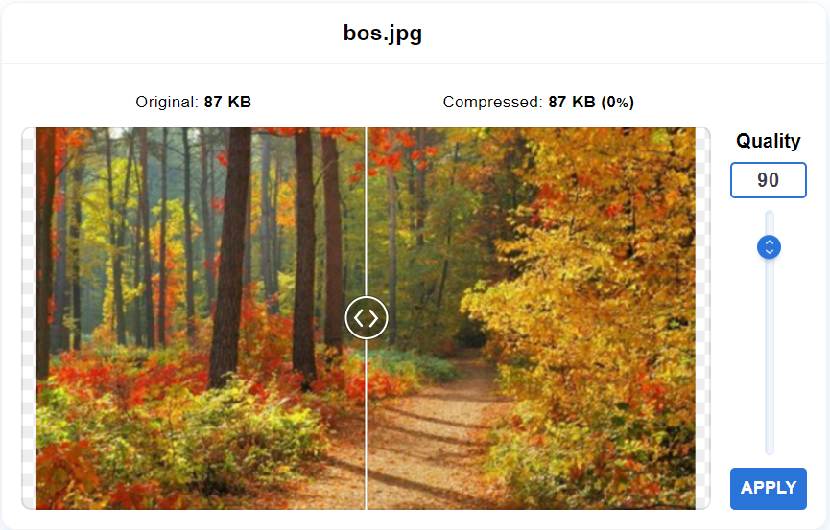

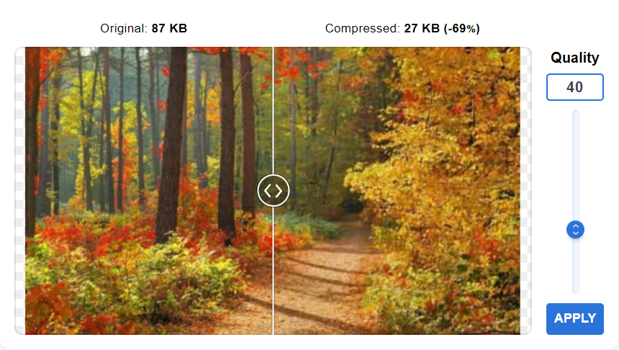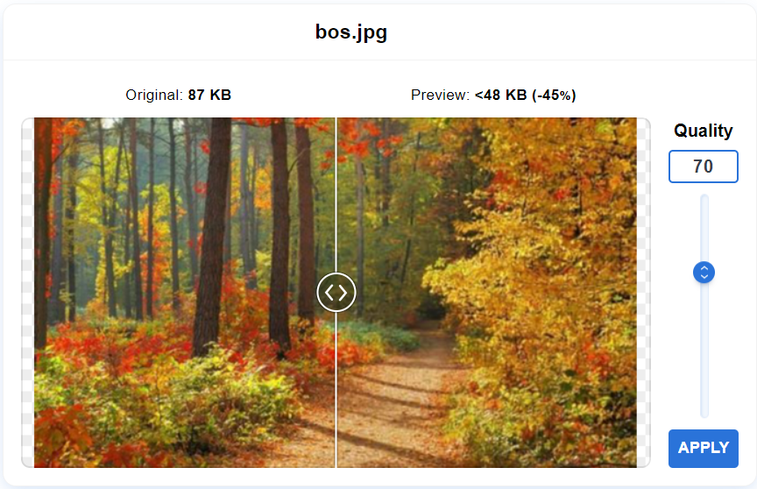

**Opdracht 3**